**Building a 3-Tier Web Application on AWS**

This project aims to build a robust 3-tier web application on AWS, leveraging multiple AWS services to ensure scalability, security, and high availability. The architecture consists of a web tier, an application tier, and a data tier, each hosted on separate subnets within a Virtual Private Cloud (VPC). The setup includes configuring network components, EC2 instances, and a LAMP server, followed by load balancing and database setup to create a fully functional and efficient web application infrastructure.

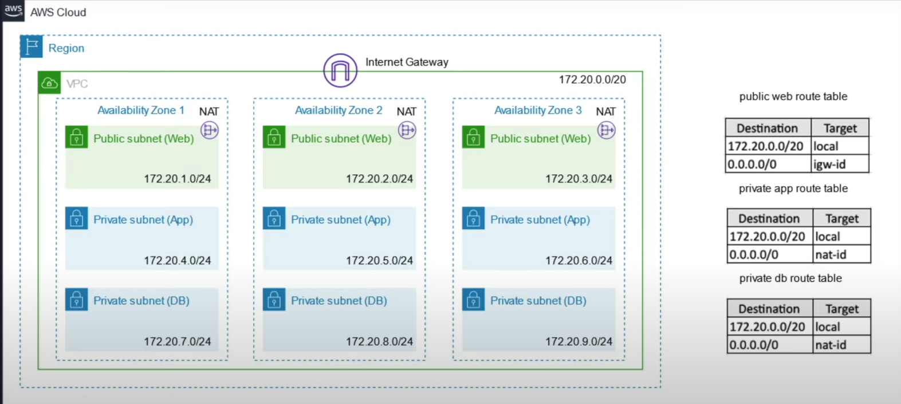

**Network Configuration**

First, create a VPC and enable DNS hostnames and settings. Attach an Internet Gateway to the VPC and create three sets of subnets: public subnets for the web tier, and private subnets for both the application and data tiers. Enable auto-assign IP addresses for the public subnets. Next, set up route tables: a public route table with a route to the Internet Gateway, and private route tables for the application and data tiers with routes to a NAT Gateway, which should be created in a public subnet with an allocated Elastic IP.

**Setting Up EC2 Instances**

Create a bastion host EC2 instance to provide secure access to instances in private subnets. Then, create two EC2 instances for the application tier and configure the bastion host to access these application servers. Establish secure connections between the bastion host and the application servers.

**Setting Up the LAMP Server**

Prepare the server by installing and configuring Apache, MariaDB, and PHP on Amazon Linux 2. Ensure all packages are up-to-date and follow the AWS tutorial for detailed installation steps. Test the LAMP server by creating a PHP file and accessing it via a web browser. Secure the database server and optionally install phpMyAdmin. Detailed instructions can be found in the AWS LAMP Setup Tutorial. https://docs.aws.amazon.com/linux/al2/ug/ec2-lamp-amazon-linux-2.html

**Load Balancer Configuration**

Create a load balancer to distribute traffic across the application servers, ensuring scalability and high availability. Set up a security group to allow traffic from the load balancer to the web servers, and define a target group to manage the application instances.

**Database Setup**

Create a subnet group for the database instances and set up the database in the appropriate subnets. Configure the necessary settings to ensure proper connectivity and security.

By following these steps, you will establish a robust and scalable 3-tier web application infrastructure on AWS, ensuring effective network connectivity, secure access, load balancing, and comprehensive database management.

